**浙大城市学院实验报告**

课程名称 计算机网络实验

实验项目名称 实验6 路由器基础与静态路由

学生姓名 司晨旭 专业班级 计算2002 学号 32001019

指导老师 蔡建平 实验日期 2022/4/1

一、实验目的

1.掌握静态路由的配置方法；

2.理解路由表的作用和原理。

二、实验设备

Cisco路由器2911；PC机。

路由模块，串口线和双绞线若干。

**三、实验配置**

**1. 实验配置一**

根据图示连接拓扑图如下：

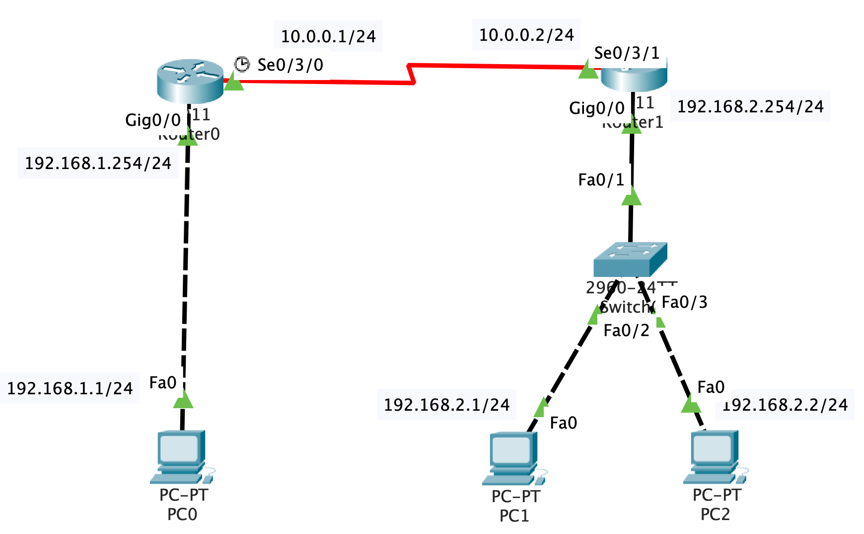

根据上图，将路由器和各主机进行连接，路由器Router1的名字标注改为你的姓名首字母的缩写，请你的拓扑图：

1.1 配置路由器的名字为R0，设置特权密码，telnet登录密码

配置命令与响应消息

|  |
| --- |
| Router>  Router>en  Router#conf t  Enter configuration commands, one per line. End with CNTL/Z.  Router(config)#hostname SCX_R0  SCX_R0(config)#enable password enzucc  SCX_R0(config)#line vty 0 4  SCX_R0(config-line)#password telzucc  SCX_R0(config-line)#login  SCX_R0(config-line)#exit |

1.2 配置端口g0/0的ip地址，并打开端口

配置Loopback的地址为1.1.1.1/32

|  |
| --- |
| SCX_R0(config)#interface loopback 0  SCX_R0(config-if)#  %LINK-5-CHANGED: Interface Loopback0, changed state to up  %LINEPROTO-5-UPDOWN: Line protocol on Interface Loopback0, changed state to up  SCX_R0(config-if)#ip address 1.1.1.1 255.255.255.255  SCX_R0(config-if)#no shutdown  SCX_R0(config-if)#exit  SCX_R0(config)#  SCX_R0(config)#interface g0/0  SCX_R0(config-if)#ip address 192.168.1.254 255.255.255.0  SCX_R0(config-if)#no shutdown  SCX_R0(config-if)#  %LINK-5-CHANGED: Interface GigabitEthernet0/0, changed state to up  %LINEPROTO-5-UPDOWN: Line protocol on Interface GigabitEthernet0/0, changed state to up |

1.3 连接完整拓扑，配置PC0的IP地址，掩码和网关，PC0以telnet方式登录R0的Loopback地址1.1.1.1，配置串口s0/3/0的IP地址为10.0.0.1/24. 截图如下：

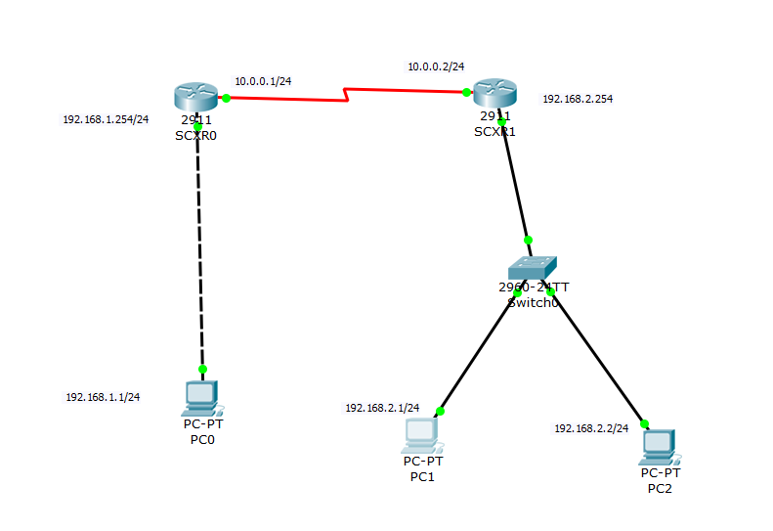

1.4 配置路由器Router1的路由器名为你的姓名首字母的缩写，配置端口S0/3/1和G0/0

配置命令与响应消息

|  |
| --- |
| SCX_R0(config)#interface loopback 0  SCX_R0(config-if)#  %LINK-5-CHANGED: Interface Loopback0, changed state to up  %LINEPROTO-5-UPDOWN: Line protocol on Interface Loopback0, changed state to up  SCX_R0(config-if)#ip address 1.1.1.1 255.255.255.255  SCX_R0(config-if)#no shutdown  SCX_R0(config-if)#exit  SCX_R0(config)# |

1.5. 查看各主机间的通讯情况：

PC0->PC2，截图如下：

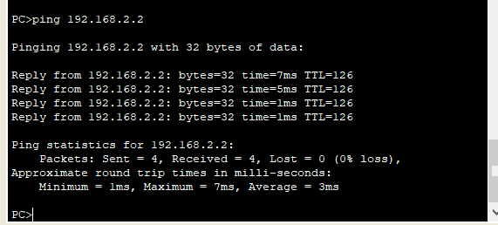

**2实验配置二**

（请注意实验作业拓扑与示例视频上的拓扑中路由器和主机编号的差异）

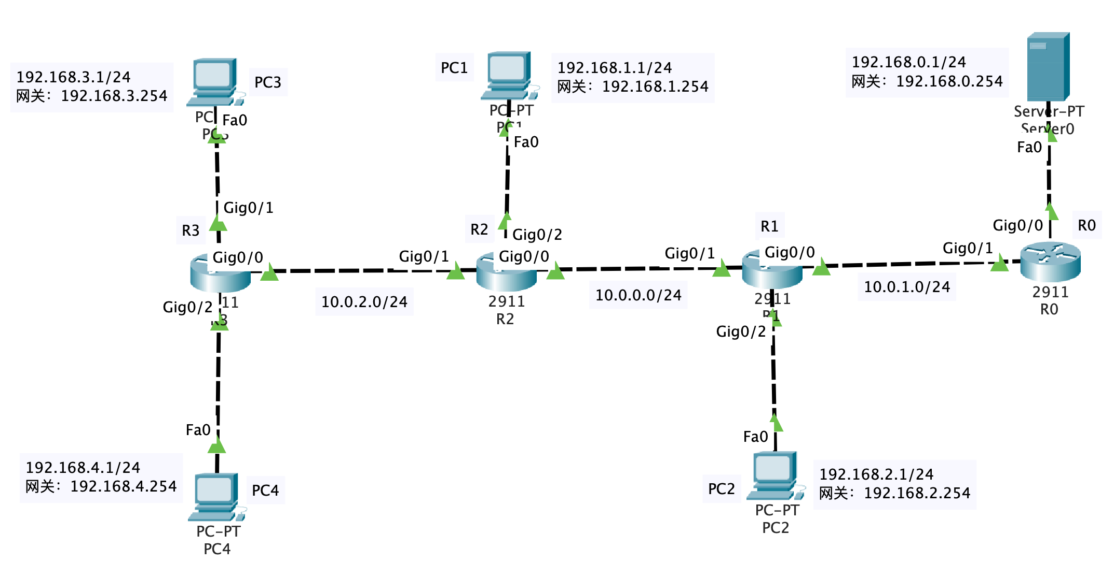

根据上图，将路由器和各主机通过Gigabit以太网接口进行连接，并将路由器Router1的名字**标注**为你的姓名首字母的缩写，请附近上你的拓扑图：

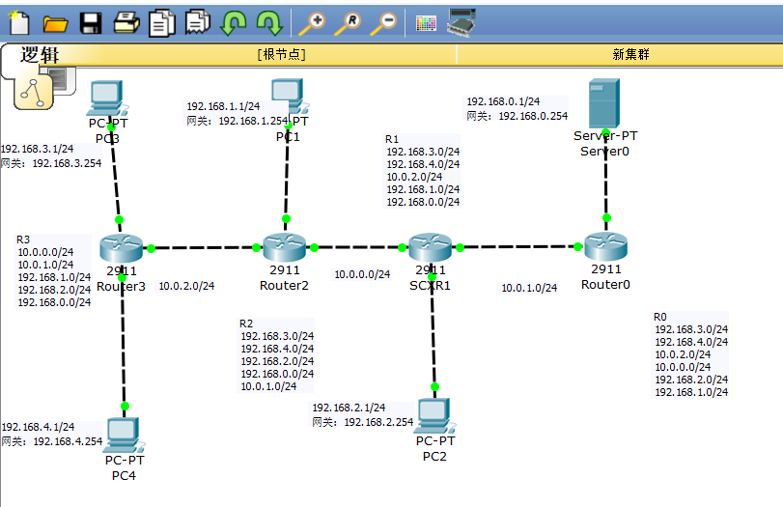

2.1 配置路由器名以及各接口的IP地址

R0的基本接口配置

|  |
| --- |
| Router>en  Router#conf t  Enter configuration commands, one per line. End with CNTL/Z.  Router(config)#hostname R0  R0(config)#interface g0/0  R0(config-if)#ip address 192.168.0.254 255.255.255.0  R0(config-if)#no shutdown  R0(config-if)#  %LINK-5-CHANGED: Interface GigabitEthernet0/0, changed state to up  %LINEPROTO-5-UPDOWN: Line protocol on Interface GigabitEthernet0/0, changed state to up  R0(config-if)#interface g0/1  R0(config-if)#ip address 10.0.1.2 255.255.255.0  R0(config-if)#no shutdown  R0(config-if)#  %LINK-5-CHANGED: Interface GigabitEthernet0/1, changed state to up  %LINEPROTO-5-UPDOWN: Line protocol on Interface GigabitEthernet0/1, changed state to up  R0(config-if)# |

R1的基本接口配置(路由器Router1的名字**修改**为你的姓名首字母的缩写)

|  |
| --- |
| Router>  Router>en  Router#conf t  Enter configuration commands, one per line. End with CNTL/Z.  Router(config)#hostname R1  R1(config)#interface g0/0  R1(config-if)#ip address 10.0.1.1 255.255.255.0  R1(config-if)#no shutdown  R1(config-if)#  %LINK-5-CHANGED: Interface GigabitEthernet0/0, changed state to up  R1(config-if)#interface g0/1  R1(config-if)#ip address 10.0.0.2 255.255.255.0  R1(config-if)#no shutdown  R1(config-if)#  %LINK-5-CHANGED: Interface GigabitEthernet0/1, changed state to up  %LINEPROTO-5-UPDOWN: Line protocol on Interface GigabitEthernet0/1, changed state to up  R1(config-if)#interface g0/2  R1(config-if)#ip address 192.168.2.254 255.255.255.0  R1(config-if)#no shutdown  R1(config-if)#  %LINK-5-CHANGED: Interface GigabitEthernet0/2, changed state to up  %LINEPROTO-5-UPDOWN: Line protocol on Interface GigabitEthernet0/2, changed state to up  R1(config-if)#  %LINEPROTO-5-UPDOWN: Line protocol on Interface GigabitEthernet0/0, changed state to up |

R2的基本接口配置

|  |
| --- |
| Router>en  Router#conf t  Enter configuration commands, one per line. End with CNTL/Z.  Router(config)#hostname R2  R2(config)#interface g0/0  R2(config-if)#ip address 10.0.0.1 255.255.255.0  R2(config-if)#no shutdown  R2(config-if)#  %LINK-5-CHANGED: Interface GigabitEthernet0/0, changed state to up  R2(config-if)#interface g0/1  R2(config-if)#ip address 10.0.2.2 255.255.255.0  R2(config-if)#no shutdown  R2(config-if)#  %LINK-5-CHANGED: Interface GigabitEthernet0/1, changed state to up  %LINEPROTO-5-UPDOWN: Line protocol on Interface GigabitEthernet0/1, changed state to up  R2(config-if)#interface g0/2  R2(config-if)#ip address 192.168.1.254 255.255.255.0  R2(config-if)#no shutdown  R2(config-if)#  %LINK-5-CHANGED: Interface GigabitEthernet0/2, changed state to up  %LINEPROTO-5-UPDOWN: Line protocol on Interface GigabitEthernet0/2, changed state to up  R2(config-if)#  R2(config-if)#  %LINEPROTO-5-UPDOWN: Line protocol on Interface GigabitEthernet0/0, changed state to up |

R3的基本接口配置

|  |
| --- |
| Router>en  Router#conf t  Enter configuration commands, one per line. End with CNTL/Z.  Router(config)#hostname R3  R3(config)#interface gi  R3(config)#interface gigabitEthernet 0/0  R3(config-if)#ip address 10.0.2.1 255.255.255.0  R3(config-if)#no shutdown  R3(config-if)#  %LINK-5-CHANGED: Interface GigabitEthernet0/0, changed state to up  R3(config-if)#interface gigabitEthernet 0/1  R3(config-if)#ip address 192.168.3.254 255.255.255.0  R3(config-if)#no shutdown  R3(config-if)#  %LINK-5-CHANGED: Interface GigabitEthernet0/1, changed state to up  %LINEPROTO-5-UPDOWN: Line protocol on Interface GigabitEthernet0/1, changed state to up  R3(config-if)#interface gigabitEthernet 0/2  R3(config-if)#ip address 192.168.4.254 255.255.255.0  R3(config-if)#no shutdown  R3(config-if)#  %LINK-5-CHANGED: Interface GigabitEthernet0/2, changed state to up  %LINEPROTO-5-UPDOWN: Line protocol on Interface GigabitEthernet0/2, changed state to up  R3(config-if)#  %LINEPROTO-5-UPDOWN: Line protocol on Interface GigabitEthernet0/0, changed state to up |

2.2 配置各主机地址、子网掩码和网关

|  |  |  |  |  |  |
| --- | --- | --- | --- | --- | --- |
|  | IP地址 | 子网掩码 | 默认网关 | 连接的路由器 | 端口号 |
| PC1 | 192.168.1.1/24 | 255.255.255.0 | 192.168.1.254 | R2 | g 0/2 |
| PC2 | 192.168.2.1/24 | 255.255.255.0 | 192.168.2.254 | R1 | g 0/2 |
| PC3 | 192.168.3.1/24 | 255.255.255.0 | 192.168.3.254 | R3 | g 0/1 |
| PC4 | 192.168.4.1/24 | 255.255.255.0 | 192.168.4.254 | R3 | g 0/2 |
| SERVER | 192.168.0.1/24 | 255.255.255.0 | 192.168.0.254 | R0 | g 0/0 |

2.3 查看各路由器的路由信息

查看路由器R0的路由信息

命令及反馈

|  |
| --- |
| R0#show ip route  Codes: L - local, C - connected, S - static, R - RIP, M - mobile, B - BGP  D - EIGRP, EX - EIGRP external, O - OSPF, IA - OSPF inter area  N1 - OSPF NSSA external type 1, N2 - OSPF NSSA external type 2  E1 - OSPF external type 1, E2 - OSPF external type 2, E - EGP  i - IS-IS, L1 - IS-IS level-1, L2 - IS-IS level-2, ia - IS-IS inter area  * - candidate default, U - per-user static route, o - ODR  P - periodic downloaded static route  Gateway of last resort is not set  10.0.0.0/8 is variably subnetted, 4 subnets, 2 masks  S 10.0.0.0/24 [1/0] via 10.0.1.1  C 10.0.1.0/24 is directly connected, GigabitEthernet0/1  L 10.0.1.2/32 is directly connected, GigabitEthernet0/1  S 10.0.2.0/24 [1/0] via 10.0.1.1  192.168.0.0/24 is variably subnetted, 2 subnets, 2 masks  C 192.168.0.0/24 is directly connected, GigabitEthernet0/0  L 192.168.0.254/32 is directly connected, GigabitEthernet0/0  S 192.168.1.0/24 [1/0] via 10.0.1.1  S 192.168.2.0/24 [1/0] via 10.0.1.1  S 192.168.3.0/24 [1/0] via 10.0.1.1  S 192.168.4.0/24 [1/0] via 10.0.1.1  R0# |

各路由器的直接网络号信息

|  |  |  |  |  |
| --- | --- | --- | --- | --- |
| 路由器 | R0 | R1 | R2 | R3 |
| 直连网络号 | 10.0.1.0/24  192.168.0.0/24 | 10.0.0.0/24  192.168.2.0/24  10.0.1.0/24 | 10.0.2.0/24  192.168.1.0/24  10.0.0.0/24 | 192.168.3.0/24  10.0.2.0/24  192.168.4.0/24 |

2.4 各路由器需要配置的静态路由表项

|  |  |  |  |  |
| --- | --- | --- | --- | --- |
| 路由器 | R0 | R1 | R2 | R3 |
| 网络号 | R0  192.168.3.0/24  192.168.4.0/24  10.0.2.0/24  10.0.0.0/24  192.168.2.0/24  192.168.1.0/24 | R1  192.168.3.0/24  192.168.4.0/24  10.0.2.0/24  192.168.1.0/24  192.168.0.0/24 | R2  192.168.3.0/24  192.168.4.0/24  192.168.2.0/24  192.168.0.0/24  10.0.1.0/24 | R3  10.0.0.0/24  10.0.1.0/24  192.168.1.0/24  192.168.2.0/24  192.168.0.0/24 |

2.5 配置HTTP服务器及修改index.html的内容，加入ZUCC NetLab等信息，截图如下：

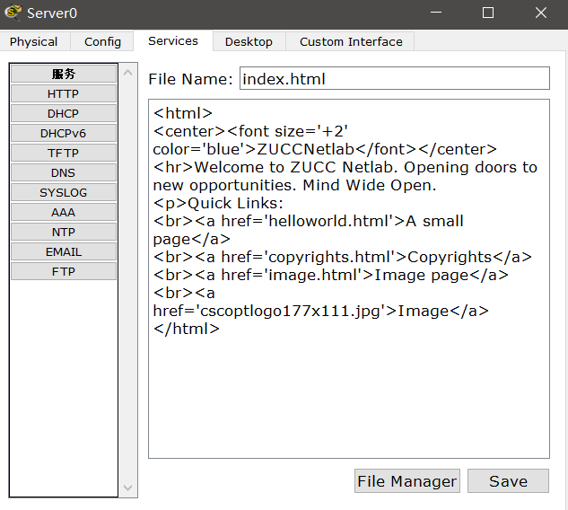

2.6 验证连通情况

在PC3与HTTP Server间添加简单PDU进行验证，截图如下：

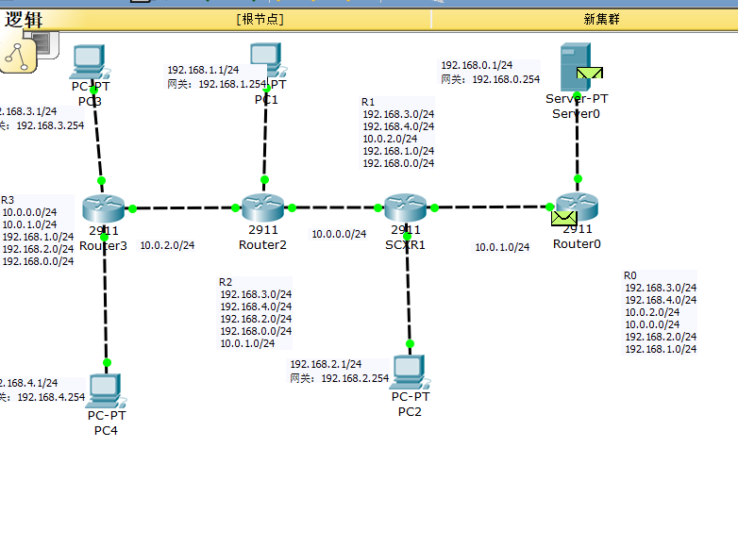

用PC4的Web浏览器访问HTTP server的页面，截图如下：

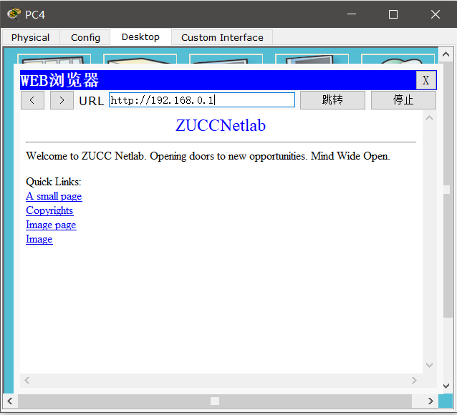

四、收获感想：

这次实验个人感觉是和理论课结合最大的，可能是因为假期多上了一节理论课才做的实验，对网络的ip地址也有了更深刻的理解